Project Planning (Product Backlog, Sprint Planning, Stories, Story Points)
AI FAQ Assistant — Backend-Only RESTful API (Node.js / Express.js / MongoDB / JWT / Gemini AI)
Field | Details
Date | 26 September 2026
Team ID | 6ab4aef20fc666a751b4634f
Project Name | AI FAQ Assistant
Maximum Marks | 5 Marks

Project Type: Backend-only RESTful API (no frontend/UI layer) — built with Node.js, Express.js, MongoDB (Mongoose), JWT authentication and the Google Gemini API; tested and consumed through Postman / client applications.
Team: Solo Developer (single-member team — all roles: design, development, testing and documentation).
Planning Approach: The 12 finalized user stories from the Requirement Analysis phase were grouped into 3 sprints of roughly 5–6 working days each (≈ 3 weeks total). Story points were estimated on a 1–5 scale from real implementation complexity: infrastructure-heavy work (JWT authentication setup) and third-party AI integration (Gemini API, structured JSON output) score high, while a single simple GET endpoint scores low.

PART 1: Product Backlog, Sprint Planning and Estimation

Table 1: Product Backlog — Sprint-wise User Stories & Story Points
Sprint | Functional Requirement (Epic) | User Story Number | User Story / Task | Story Points | Priority | Team Members
Sprint-1 | Registration | USN-1 | As a guest user, I can register for an account by providing my name, email and password, so that I can gain access to FAQ management and AI features. | 3 | High | Solo Developer
Sprint-1 | Login | USN-2 | As a registered user, I can log in with my email and password, so that I receive a JWT token for accessing protected endpoints. | 2 | High | Solo Developer
Sprint-1 | Profile Management | USN-3 | As a registered user, I can view my profile by sending my JWT token, so that I can see my stored account details. | 2 | Medium | Solo Developer
Sprint-1 | FAQ Creation | USN-4 | As a registered user, I can create a new FAQ by providing a question, answer and valid category, so that it is stored and becomes available to everyone. | 2 | High | Solo Developer
Sprint-1 | FAQ Update & Deletion | USN-5 | As a registered user, I can update an FAQ I created (question, answer and/or category), so that I can keep my content accurate. | 2 | Medium | Solo Developer
Sprint-1 | FAQ Update & Deletion | USN-6 | As a registered user, I can delete an FAQ I created, so that outdated content is removed from the system. | 2 | Medium | Solo Developer
Sprint-1 | FAQ Listing & Retrieval | USN-7 | As a guest user, I can browse all FAQs without logging in, so that I can read the knowledge base. | 3 | High | Solo Developer
Sprint-2 | FAQ Listing & Retrieval | USN-8 | As a guest user, I can retrieve a single FAQ by its ID, so that I can view a specific entry. | 1 | Medium | Solo Developer
Sprint-2 | FAQ Search | USN-9 | As a guest user, I can search FAQs by keyword, so that I can quickly find relevant entries. | 4 | Medium | Solo Developer
Sprint-2 | AI Answer Generation | USN-10 | As a registered user, I can submit any free-text question to the AI, so that I receive a direct, concise answer. | 5 | High | Solo Developer
Sprint-3 | AI FAQ Generation | USN-11 | As a registered user, I can provide a topic and have the AI generate an FAQ pair, so that I can author content faster. | 4 | Medium | Solo Developer
Sprint-3 | AI FAQ Generation | USN-12 | As a registered user, I can save an AI-generated FAQ pair via the Create FAQ endpoint, so that it is stored permanently in the FAQ collection. | 2 | Medium | Solo Developer
 |  |  | Total | 32

Table 1a: Sprint-wise Backlog Summary
Sprint | Scope Covered | User Stories | Story Points
Sprint-1 | Core authentication (register, login, profile) + FAQ CRUD + FAQ listing | USN-1 to USN-7 | 16
Sprint-2 | FAQ retrieval by ID + keyword search + AI answer generation | USN-8 to USN-10 | 10
Sprint-3 | AI FAQ generation + saving the generated FAQ + final testing & polish | USN-11 to USN-12 | 6
 | Total |  | 32

Estimation basis (why these points):
USN-1 — Registration (3 pts, High): more than a plain create endpoint — bcrypt password hashing (10 salt rounds), duplicate-email check, input validation and JWT issuance on top of the User model.
USN-2 — Login (2 pts, High): reuses the User model and bcrypt comparison; only credential verification and token issue remain.
USN-3 — Profile (2 pts, Medium): small once the JWT verification middleware exists (Sprint-1), but still needs a protected route and a password-excluded response.
USN-4 — FAQ Creation (2 pts, High): Mongoose schema plus category-enum validation and creator (createdBy) stamping.
USN-5 — Update FAQ (2 pts, Medium): CRUD update plus creator-ownership check returning 403 for non-creators.
USN-6 — Delete FAQ (2 pts, Medium): same ownership-check pattern as update, plus 404 handling for missing IDs.
USN-7 — FAQ Listing (3 pts, High): public read of the whole collection with newest-first sorting and creator name/email population (join across two collections).
USN-8 — Get FAQ by ID (1 pt, Medium): single findById with ObjectId/cast-error and 404 handling — the smallest story in the backlog.
USN-9 — FAQ Search (4 pts, Medium): case-insensitive regex matching across three fields (question, answer, category) with input escaping and edge-case handling — noticeably more than a basic query.
USN-10 — AI Answer Generation (5 pts, High): highest-complexity story — new Gemini SDK integration, service-layer design, prompt design for concise answers, error/timeout handling and API-latency management.
USN-11 — AI FAQ Generation (4 pts, Medium): reuses the Gemini integration but needs structured JSON-schema output, response parsing and validation of the returned {question, answer} pair.
USN-12 — Save Generated FAQ (2 pts, Medium): the generated pair is persisted through the existing Create FAQ endpoint, so it is mostly wiring plus validation of the category.

PART 2: Project Tracker, Velocity & Burndown Chart

Table 2: Project Tracker — Sprint Status (All Sprints Completed)
Sprint | Total Story Points | Duration | Sprint Start Date | Sprint End Date (Planned) | Story Points Completed (as on Planned End Date) | Sprint Release Date (Actual)
Sprint-1 | 16 | 6 days | 31 Aug 2026 | 5 Sep 2026 | 16 | 5 Sep 2026
Sprint-2 | 10 | 6 days | 7 Sep 2026 | 12 Sep 2026 | 10 | 13 Sep 2026
Sprint-3 | 6 | 5 days | 14 Sep 2026 | 18 Sep 2026 | 6 | 19 Sep 2026
Total | 32 | 17 days | 31 Aug 2026 | 18 Sep 2026 | 32 | 19 Sep 2026

All three sprints are completed — every planned user story was finished and released. Sprint-1 was delivered on the planned date; Sprint-2 and Sprint-3 each slipped by one day (extra Gemini-integration debugging and final regression testing), but no story was dropped.
Velocity Calculation
Velocity is calculated the same way as in the template example — the total story points completed in a sprint, divided by the sprint duration in days, gives the average velocity (AV) per day.
Sprint | Sprint Duration | Velocity (points per sprint) | Calculation | Average Velocity (AV) per day
Sprint-1 | 6 days | 16 points | 16 ÷ 6 | ≈ 2.67 points/day
Sprint-2 | 6 days | 10 points | 10 ÷ 6 | ≈ 1.67 points/day
Sprint-3 | 5 days | 6 points | 6 ÷ 5 | ≈ 1.20 points/day

Overall project velocity:
Total story points delivered = 16 + 10 + 6 = 32 points over 17 working days
Overall average velocity per day = 32 ÷ 17 = ≈ 1.88 points/day
Average velocity per sprint = 32 ÷ 3 = ≈ 10.67 points/sprint
(Velocity declines across sprints because the remaining backlog contains fewer, more research-heavy stories — Sprint-3 held only the two AI-authoring stories plus testing/polish, so fewer points were burned per day even though the work was complete.)
Burndown Chart (Description)
The burndown chart is plotted per sprint, with the number of days on the X-axis and the story points remaining on the Y-axis, and it would show the following:
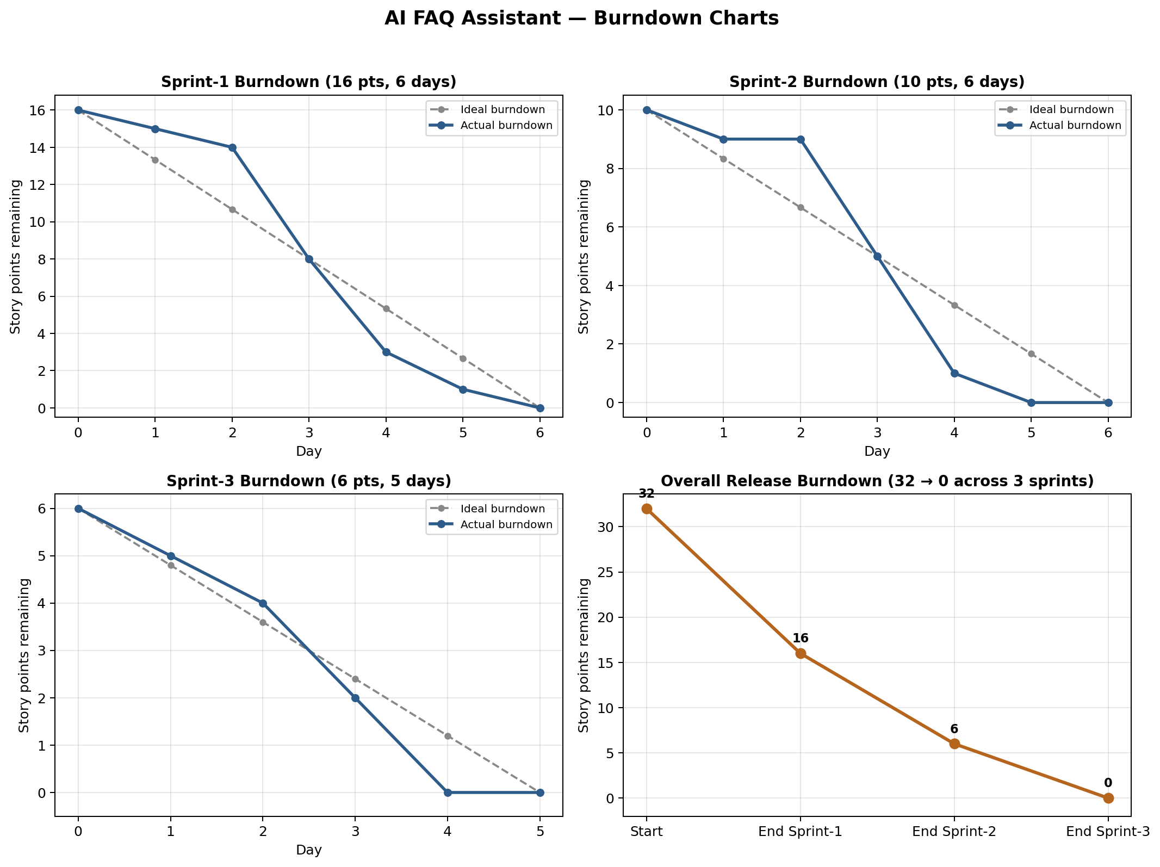
Figure 1: Sprint and Overall Release Burndown Charts
Sprint-1 (16 points over 6 days): the ideal burndown line is a straight diagonal from 16 points on Day 1 down to 0 on Day 6 (≈ 2.67 points/day). The actual line starts flatter than ideal for the first two days, because the opening work was project scaffolding, MongoDB connection, the JWT verification middleware and the validation middleware — effort with no story points burned yet. From Day 3 onward the actual line drops steeply as the registration, login, profile and FAQ CRUD stories are completed in a batch, meeting the ideal line around Day 4 and reaching 0 points on Day 6.
Sprint-2 (10 points over 6 days): the ideal line runs from 10 points to 0 (≈ 1.67 points/day). The actual line is almost flat for the first two days while the Gemini SDK integration and prompt design for USN-10 were being trialled, then falls sharply when the AI answer endpoint works, followed by the search (USN-9) and get-by-ID (USN-8) stories — touching 0 points on Day 5, one day ahead of the ideal line, with the remaining day used for Postman verification and fixes.
Sprint-3 (6 points over 5 days): the ideal line runs from 6 points to 0 (≈ 1.20 points/day). The actual line stays near the ideal for the first two days (structured JSON-schema output and parsing for USN-11), then drops to 0 on Day 4–5 once USN-12 is wired into the Create FAQ endpoint, with the remaining time spent on final testing and polish.
Overall (release) burndown across the 3 sprints: a combined chart would show the remaining backlog falling 32 → 16 → 6 → 0 at the end of Sprint-1, Sprint-2 and Sprint-3 respectively — the actual line tracking at or below the ideal line and reaching zero at the end of every sprint, since all planned stories were completed in every sprint.

